Cloud computing has introduced a whole new world of connectedness. This has led to APIs driving more and more software systems.

In JSON Format

JSON is just a format for mapping keys to values.

Settings -> Developer Settings

Must have admin rights to repository.

Preview the headers, view the key and value.

Send-> No responses now, 204 no content, Content has been removed and command was successful.

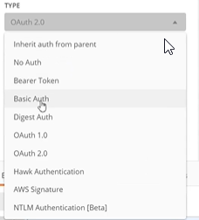

Types of Authorization

Basic Auth: Username and password

API Changing: APIs can change specially 3 rd party apis. What if version and functionality changes.

Availability: Communicating over an API, what happens if the network goes down, what happens if you send a api call and for some reason it does not come back.

Timing of responses: What happens if a call is out of order, what happens if a call is really slow and takes a long time to come back, what happens if the calls come in a different order than we expect.

Performance: APIs are called programmatically, we call them with code. How well does our server handle a lot of calls in a short amount of time. How well does it scale as the calls increase.

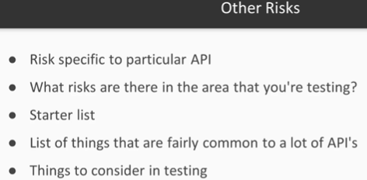

Clone the repo using github desktop.

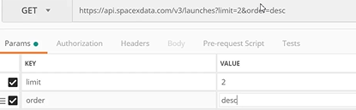

Query parameters or query string parameters.





Testing get calls

Testing post calls

Get calls, read data, don’t change anything.

Post, put and delete calls now.

Edit it.

Created the post, but set the value of id to null.

PUT Calls, change id to 2 in body and try to post it.

Look down,

Did not change the id for us.

Try to change one of the comments.

Changed.

We see that the embedded comment has changed.



Try to change the second comment, we see unauthorized.

If we show the unauthorized status, it shows that the resource exists, better to return the 404 object doesn’t exist error.

Try and delte the profile and see what happens.

We get a empty response.

Now we see no blogposts. So the blogposts associated with the user profile have been removed.

List of request types.

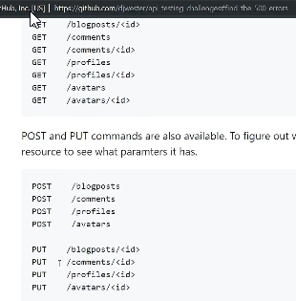

Use one of the urls.

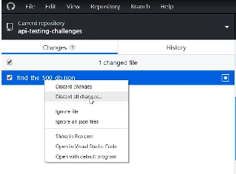

Find bugs, reset the changes in github desktop.

Description: Tells what this test/collection is doing.

Authorization: Specify once here

Will run before every request

Will run after every request

Define variables that can be used for all requests in this collection.

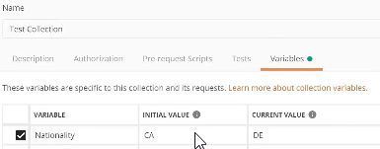

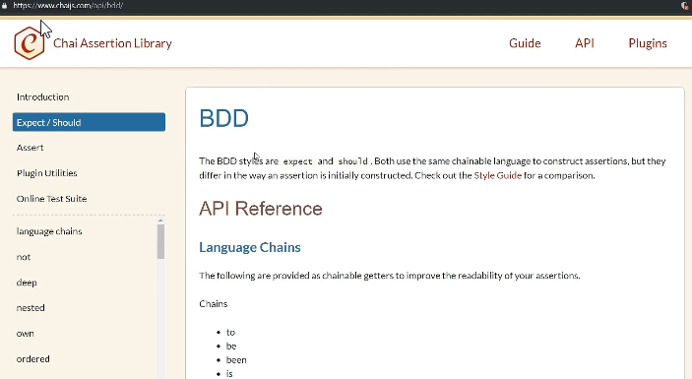Now we get back a german address.

Postman uses the chai assertion library.

Add the test in the tests section of the collection.

Environments

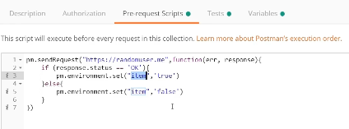Environment Quick Look

Create a mock server

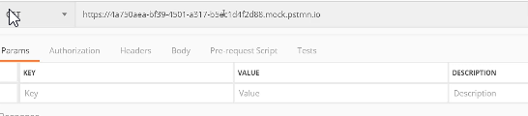

Points to a local server that Postman has made.

Add Example: Save this as an example.



Add ?nat=DE

Export the test collection.



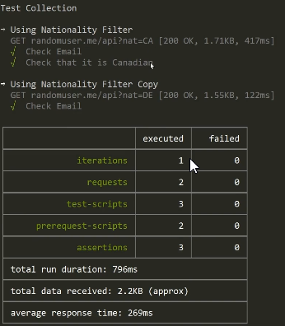Use the second json to define the environment for the first json

Open Postman Console: Bottom left,



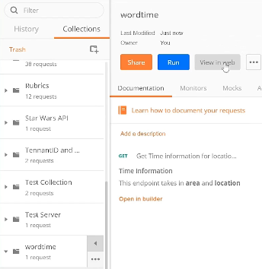

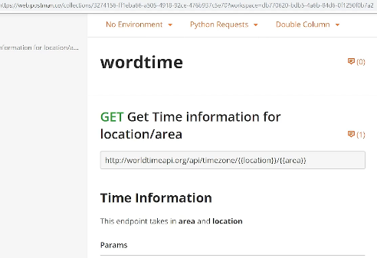Wordtime view in web.

Login to web.postman.co/workspaces

Click on Postman API -> Get an API Key

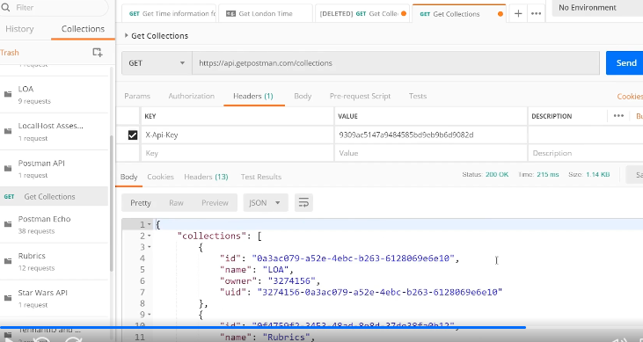

Postman API: Right click -> Create Request



Using star wars api. Takes 3 iterations to pass.

File -> Open new runner window.

Select the star wars API, Data -> Select file, Choose ready made csv file,

Can select Preview.

Set address of the address returned by ipconfig. Port: 5555 default port used by postman.

Go to swapi.co

We go back to postman and see that it has captured the network requests.